SNOWFLAKE CODING ASSESSMENT

A retail company receives daily order files from its sales application.
The source application uploads CSV files into an Azure Storage Account.
Snowflake should automatically load the new files whenever they arrive in Azure Storage.
The company wants:
1. A separate Snowflake warehouse for loading data
2. A separate user and role for data engineering
3. Data ingestion from Azure Storage Account
4. Initial load from CSV file
5. Automatic incremental loading when new CSV files are uploaded
6. Avoid duplicate records in the final table

Important Concept for Students
Snowflake does not automatically detect new rows added inside the same old file.
Best practice is:
Do not edit the already uploaded CSV file.
Instead, upload a new CSV file for every new batch.
Example:
retail_orders_initial.csv
retail_orders_incremental_20260508.csv
retail_orders_incremental_20260509.csv
retail_orders_incremental_20260510.csv
Snowpipe detects and loads new files, not newly edited rows inside the same file.

A: Snowflake Setup
- Create a database named RETAIL_DB.
CREATE OR REPLACE DATABASE RETAIL_DB;

- Create a schema named RETAIL_DB.ORDERS_DEMO.
CREATE OR REPLACE SCHEMA RETAIL_DB.ORDERS_DEMO;

- Create a warehouse named RETAIL_LOAD_WH.
CREATE OR REPLACE WAREHOUSE RETAIL_LOAD_WH
WITH
WAREHOUSE_SIZE = 'XSMALL'
AUTO_SUSPEND = 60
AUTO_RESUME = TRUE;

- Create a role named RETAIL_DATA_ENGINEER_ROLE.
CREATE OR REPLACE ROLE RETAIL_DATA_ENGINEER_ROLE;

- Create a user named RETAIL_ENGINEER_USER.
CREATE OR REPLACE USER RETAIL_ENGINEER_USER
PASSWORD = 'Retail@12345'
FIRST_NAME = 'Retail'
LAST_NAME = 'Engineer_User'
DEFAULT_ROLE = RETAIL_DATA_ENGINEER_ROLE
DEFAULT_WAREHOUSE = RETAIL_LOAD_WH
MUST_CHANGE_PASSWORD = FALSE;

- Grant required permissions to the role and user.
GRANT ROLE RETAIL_DATA_ENGINEER_ROLE TO USER RETAIL_ENGINEER_USER;

GRANT USAGE ON WAREHOUSE RETAIL_LOAD_WH TO ROLE RETAIL_DATA_ENGINEER_ROLE;
GRANT USAGE ON DATABASE RETAIL_DB TO ROLE RETAIL_DATA_ENGINEER_ROLE;
GRANT USAGE ON SCHEMA RETAIL_DB.ORDERS_DEMO TO ROLE RETAIL_DATA_ENGINEER_ROLE;

GRANT CREATE TABLE, CREATE STAGE, CREATE FILE FORMAT, CREATE PIPE
ON SCHEMA RETAIL_DB.ORDERS_DEMO TO ROLE RETAIL_DATA_ENGINEER_ROLE;

Part B: Azure Storage Setup
- Create an Azure Storage Account.
ADLS name: retailstorageadlssonali

- Create a container named retail-data.
- Inside the container, create this folder path:
raw/orders/
- Upload the initial CSV file:
retail_orders_initial.csv
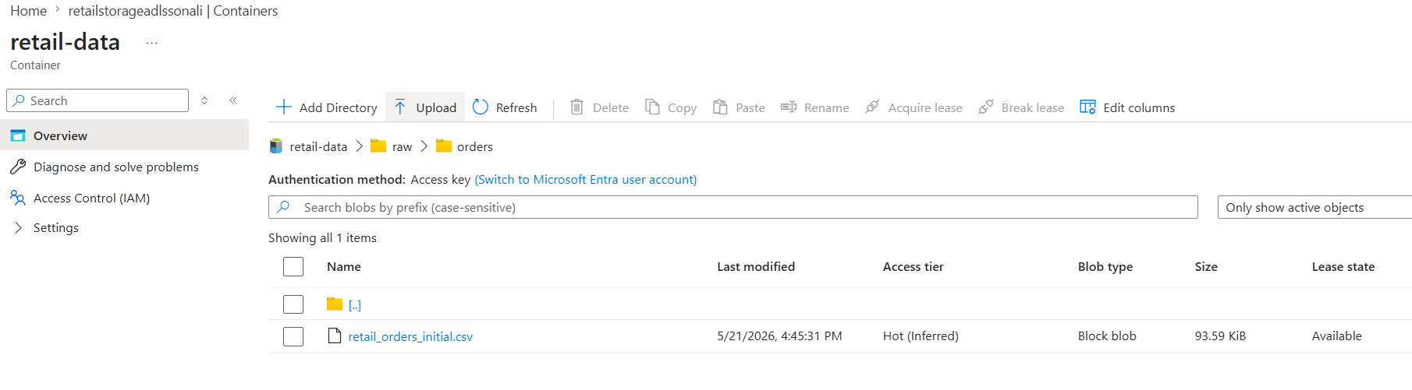

Part C: Snowflake External Stage
- Create a file format for CSV.
CREATE OR REPLACE FILE FORMAT RETAIL_DB.ORDERS_DEMO.FILE_FORMAT_CSV
TYPE= 'CSV'
FIELD_DELIMITER = ','
SKIP_HEADER = 1;

- Create an Azure storage integration or external stage.
Generate SAS Token to create external stage:
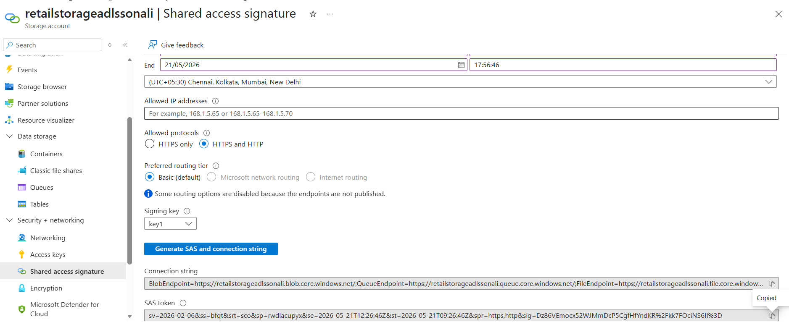

- Create an external stage pointing to:
azure://<storage_account>.blob.core.windows.net/retail-data/raw/orders/

CREATE OR REPLACE STAGE RETAIL_DB.ORDERS_DEMO.RETAIL_ORDERS_STAGE
url = 'azure://retailstorageadlssonali.blob.core.windows.net/retail-data/raw/orders/'
CREDENTIALS = (
AZURE_SAS_TOKEN = 'sv=2026-02-06&ss=bfqt&srt=sco&sp=rwdlacupyx&se=2026-05-22T14:28:18Z&st=2026-05-21T12:28:18Z&spr=https&sig=d16WMhq7eLuRZjJ9w8po%2FqgP%2FlqwYzsyyCn%2BD2ctzm8%3D'
)
FILE_FORMAT = RETAIL_DB.ORDERS_DEMO.FILE_FORMAT_CSV;

- List files from the stage.
LIST @RETAIL_DB.ORDERS_DEMO.RETAIL_ORDERS_STAGE;
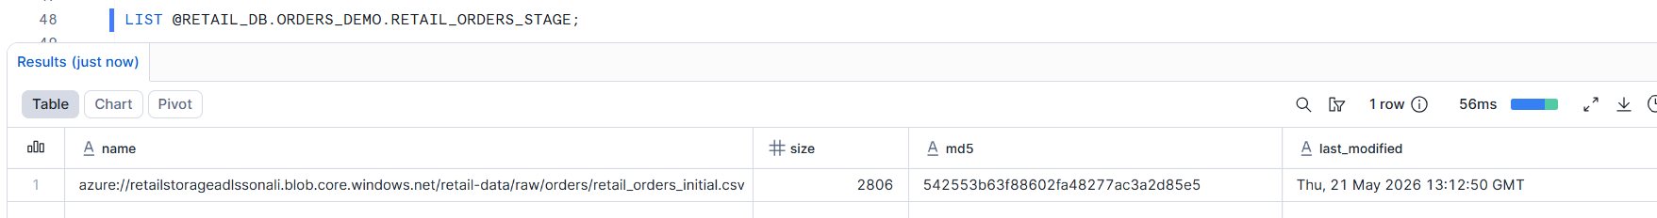

Part D: Initial Data Load
- Create a raw landing table named ORDERS_RAW.
CREATE OR REPLACE TABLE RETAIL_DB.ORDERS_DEMO.ORDERS_RAW (
ORDER_ID INT,
PRODUCT_ID STRING,
PRODUCT_NAME STRING,
QUANTITY INT,
PRICE NUMBER(10,2),
ORDER_DATE DATE
);
- Create a final table named ORDERS_FINAL.
CREATE OR REPLACE TABLE RETAIL_DB.ORDERS_DEMO.ORDERS_FINAL (
ORDER_ID INT,
PRODUCT_ID STRING,
PRODUCT_NAME STRING,
QUANTITY INT,
PRICE NUMBER(10,2),
ORDER_DATE DATE
);

- Load the initial file into ORDERS_RAW.
COPY INTO RETAIL_DB.ORDERS_DEMO.ORDERS_RAW (
ORDER_ID, PRODUCT_ID, PRODUCT_NAME, QUANTITY, PRICE, ORDER_DATE
)
FROM (
SELECT $1::INT,
$12:: STRING,
$11::STRING,
$15::INT,
$14::NUMBER(10,2),
$2::DATE
FROM @RETAIL_DB.ORDERS_DEMO.RETAIL_ORDERS_STAGE
)
FILE_FORMAT = RETAIL_DB.ORDERS_DEMO.FILE_FORMAT_CSV
files = ('retail_orders_initial.csv');

SELECT * FROM RETAIL_DB.ORDERS_DEMO.ORDERS_RAW;

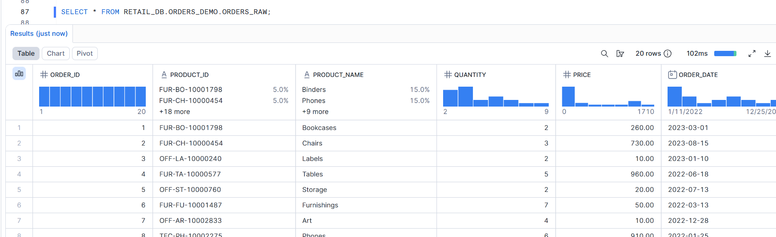

- Insert data into ORDERS_FINAL.
INSERT INTO RETAIL_DB.ORDERS_DEMO.ORDERS_FINAL
SELECT * FROM RETAIL_DB.ORDERS_DEMO.ORDERS_RAW;

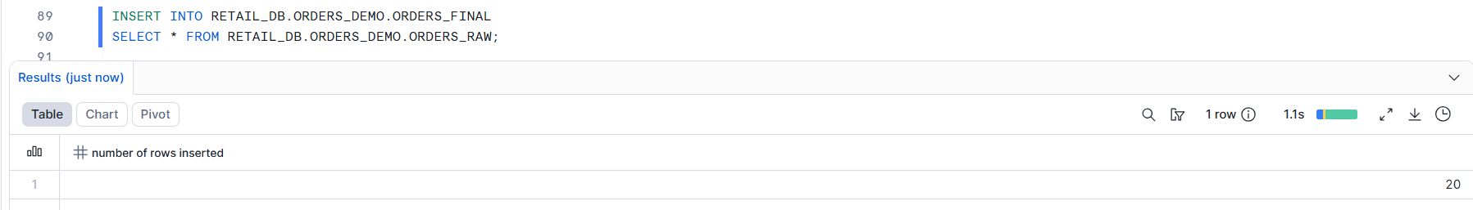

20 RECORDS IN ORDERS_FINAL
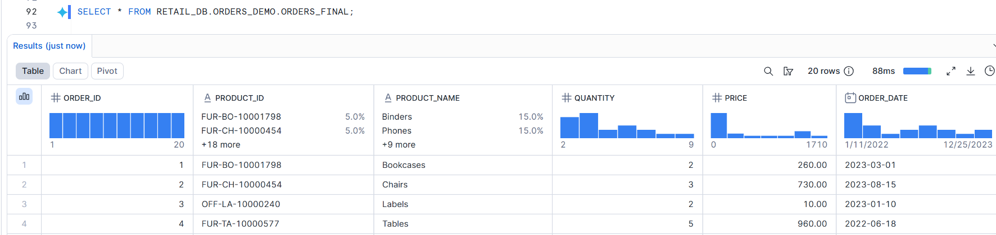

Part E: Incremental Loading
- Create a Snowpipe object to load new files automatically into ORDERS_RAW.
CREATE OR REPLACE PIPE RETAIL_DB.ORDERS_DEMO.RETAIL_ORDERS_PIPE
AS
COPY INTO RETAIL_DB.ORDERS_DEMO.ORDERS_RAW(
ORDER_ID,PRODUCT_ID,PRODUCT_NAME,QUANTITY,PRICE,ORDER_DATE)
FROM (
SELECT
$1::INT,
$12::STRING,
$11::STRING,
$15::INT,
$14::NUMBER(10,2),
$2::DATE
FROM @RETAIL_DB.ORDERS_DEMO.RETAIL_ORDERS_STAGE
)
FILE_FORMAT = RETAIL_DB.ORDERS_DEMO.FILE_FORMAT_CSV;

- Create a stream on ORDERS_RAW.
CREATE OR REPLACE STREAM RETAIL_DB.ORDERS_DEMO.ORDERS_RAW_STREAM
ON TABLE RETAIL_DB.ORDERS_DEMO.ORDERS_RAW;

- Create a task to merge new rows from the stream into ORDERS_FINAL.
CREATE OR REPLACE TASK RETAIL_DB.ORDERS_DEMO.ORDERS_MERGE_TASK
WAREHOUSE = RETAIL_LOAD_WH
SCHEDULE = '1 MINUTE'
AS
MERGE INTO RETAIL_DB.ORDERS_DEMO.ORDERS_FINAL F
USING (
SELECT ORDER_ID, PRODUCT_ID, PRODUCT_NAME, QUANTITY, PRICE, ORDER_DATE
FROM RETAIL_DB.ORDERS_DEMO.ORDERS_RAW_STREAM
WHERE METADATA$ACTION = 'INSERT'
) S
ON F.ORDER_ID = S.ORDER_ID
WHEN NOT MATCHED THEN
INSERT (ORDER_ID,PRODUCT_ID,PRODUCT_NAME,QUANTITY,PRICE,ORDER_DATE)
VALUES
(S.ORDER_ID,S.PRODUCT_ID,S.PRODUCT_NAME,S.QUANTITY,S.PRICE,S.ORDER_DATE);

- Upload another CSV file into Azure Storage.

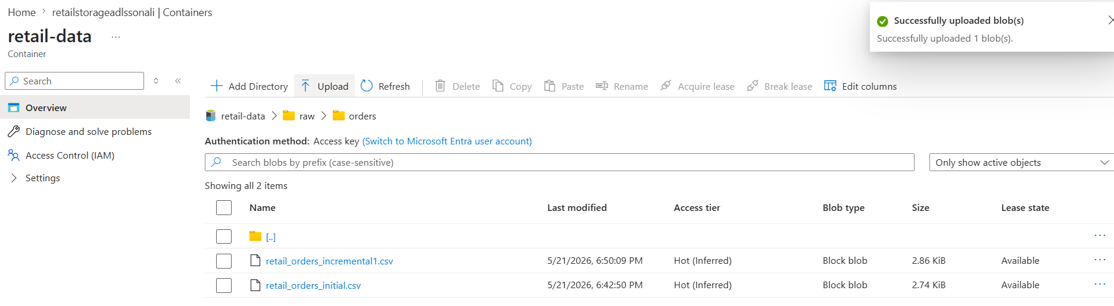

REFRESH SNOWPIPE
ALTER PIPE RETAIL_DB.ORDERS_DEMO.RETAIL_ORDERS_PIPE REFRESH;
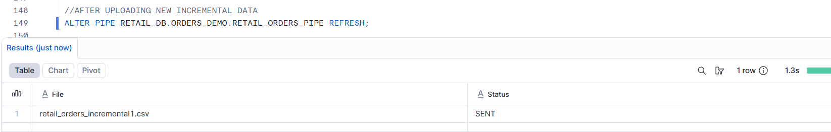

EXECUTE TASK OR LET IT RUN AUTOMATICALLY BASED ON DEFINED SCHEDULE
EXECUTE TASK RETAIL_DB.ORDERS_DEMO.ORDERS_MERGE_TASK;
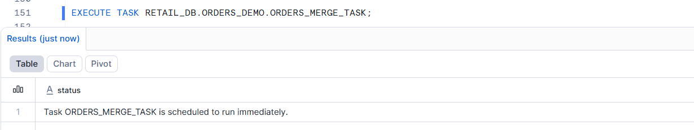

- Verify that new rows are automatically loaded into Snowflake.
SELECT * FROM RETAIL_DB.ORDERS_DEMO.ORDERS_FINAL;
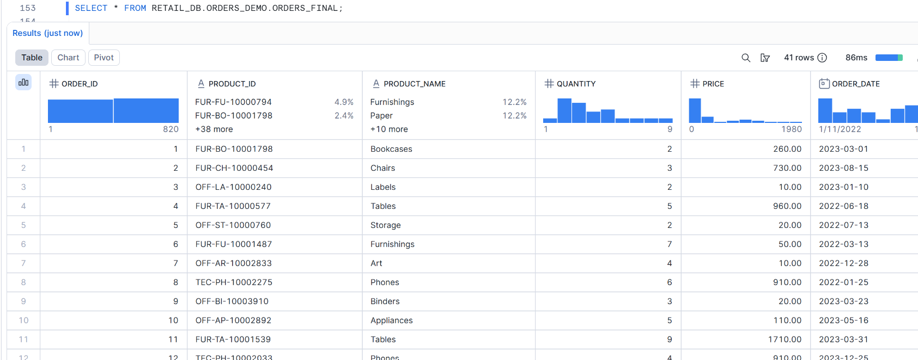
41 RECORDS IN ORDERS_FINAL NOW

